Advanced Game Programming

Jerry Järvelä / AA2890 / Portfolio

These are the Unity projects I have worked on and learned from the course Advanced Game Programming.

Tower Defense 3D

This was my first technical challenge I had to create, it’s very brief example but I was able to figure out how object pooling works. Using waypoints I can determine the path which the enemy will take, which paths are walkable and which blocks you can place down towers. Also made a debug command “C” where you can check the grid tiles.

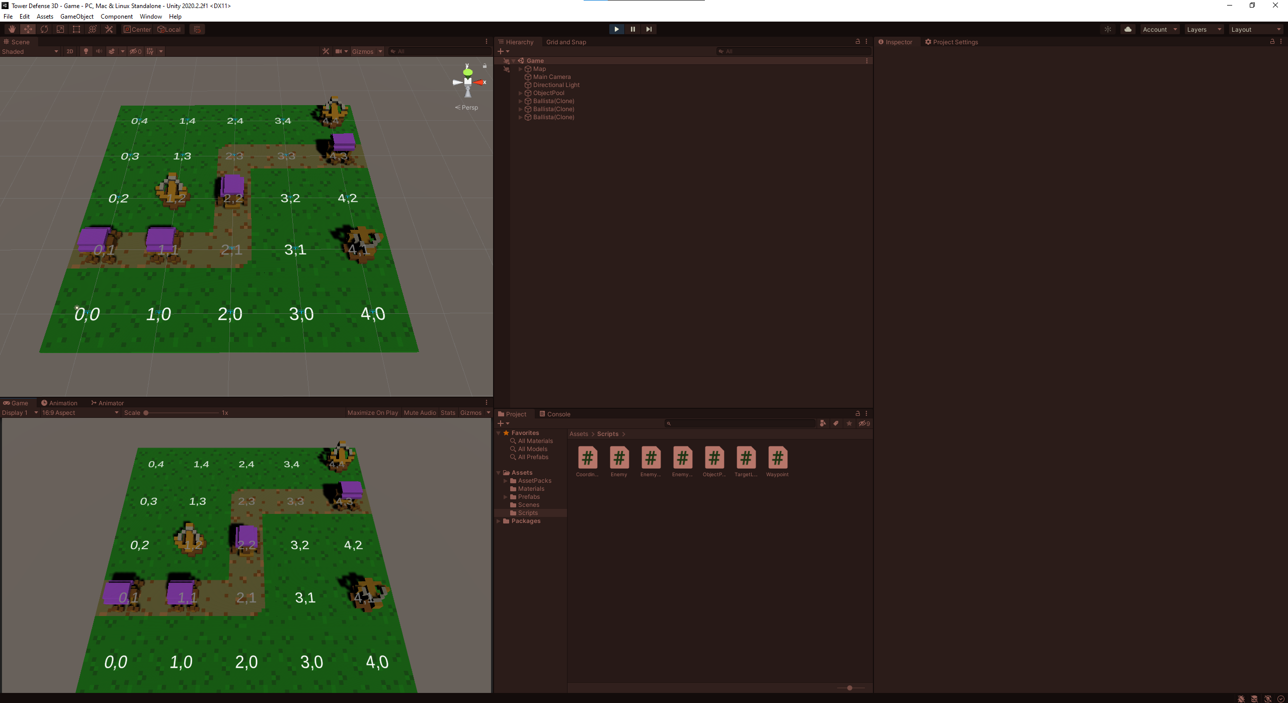

Basic ARPG Movement

I’ve made a very basic ARPG movement prototype with targeting and attacking included. I managed to create it without any dependency loops which we all know are evil. Started to use Namespaces here as I might explore and continue on this project later, so I made sure I’ve a good foundation of sorting.

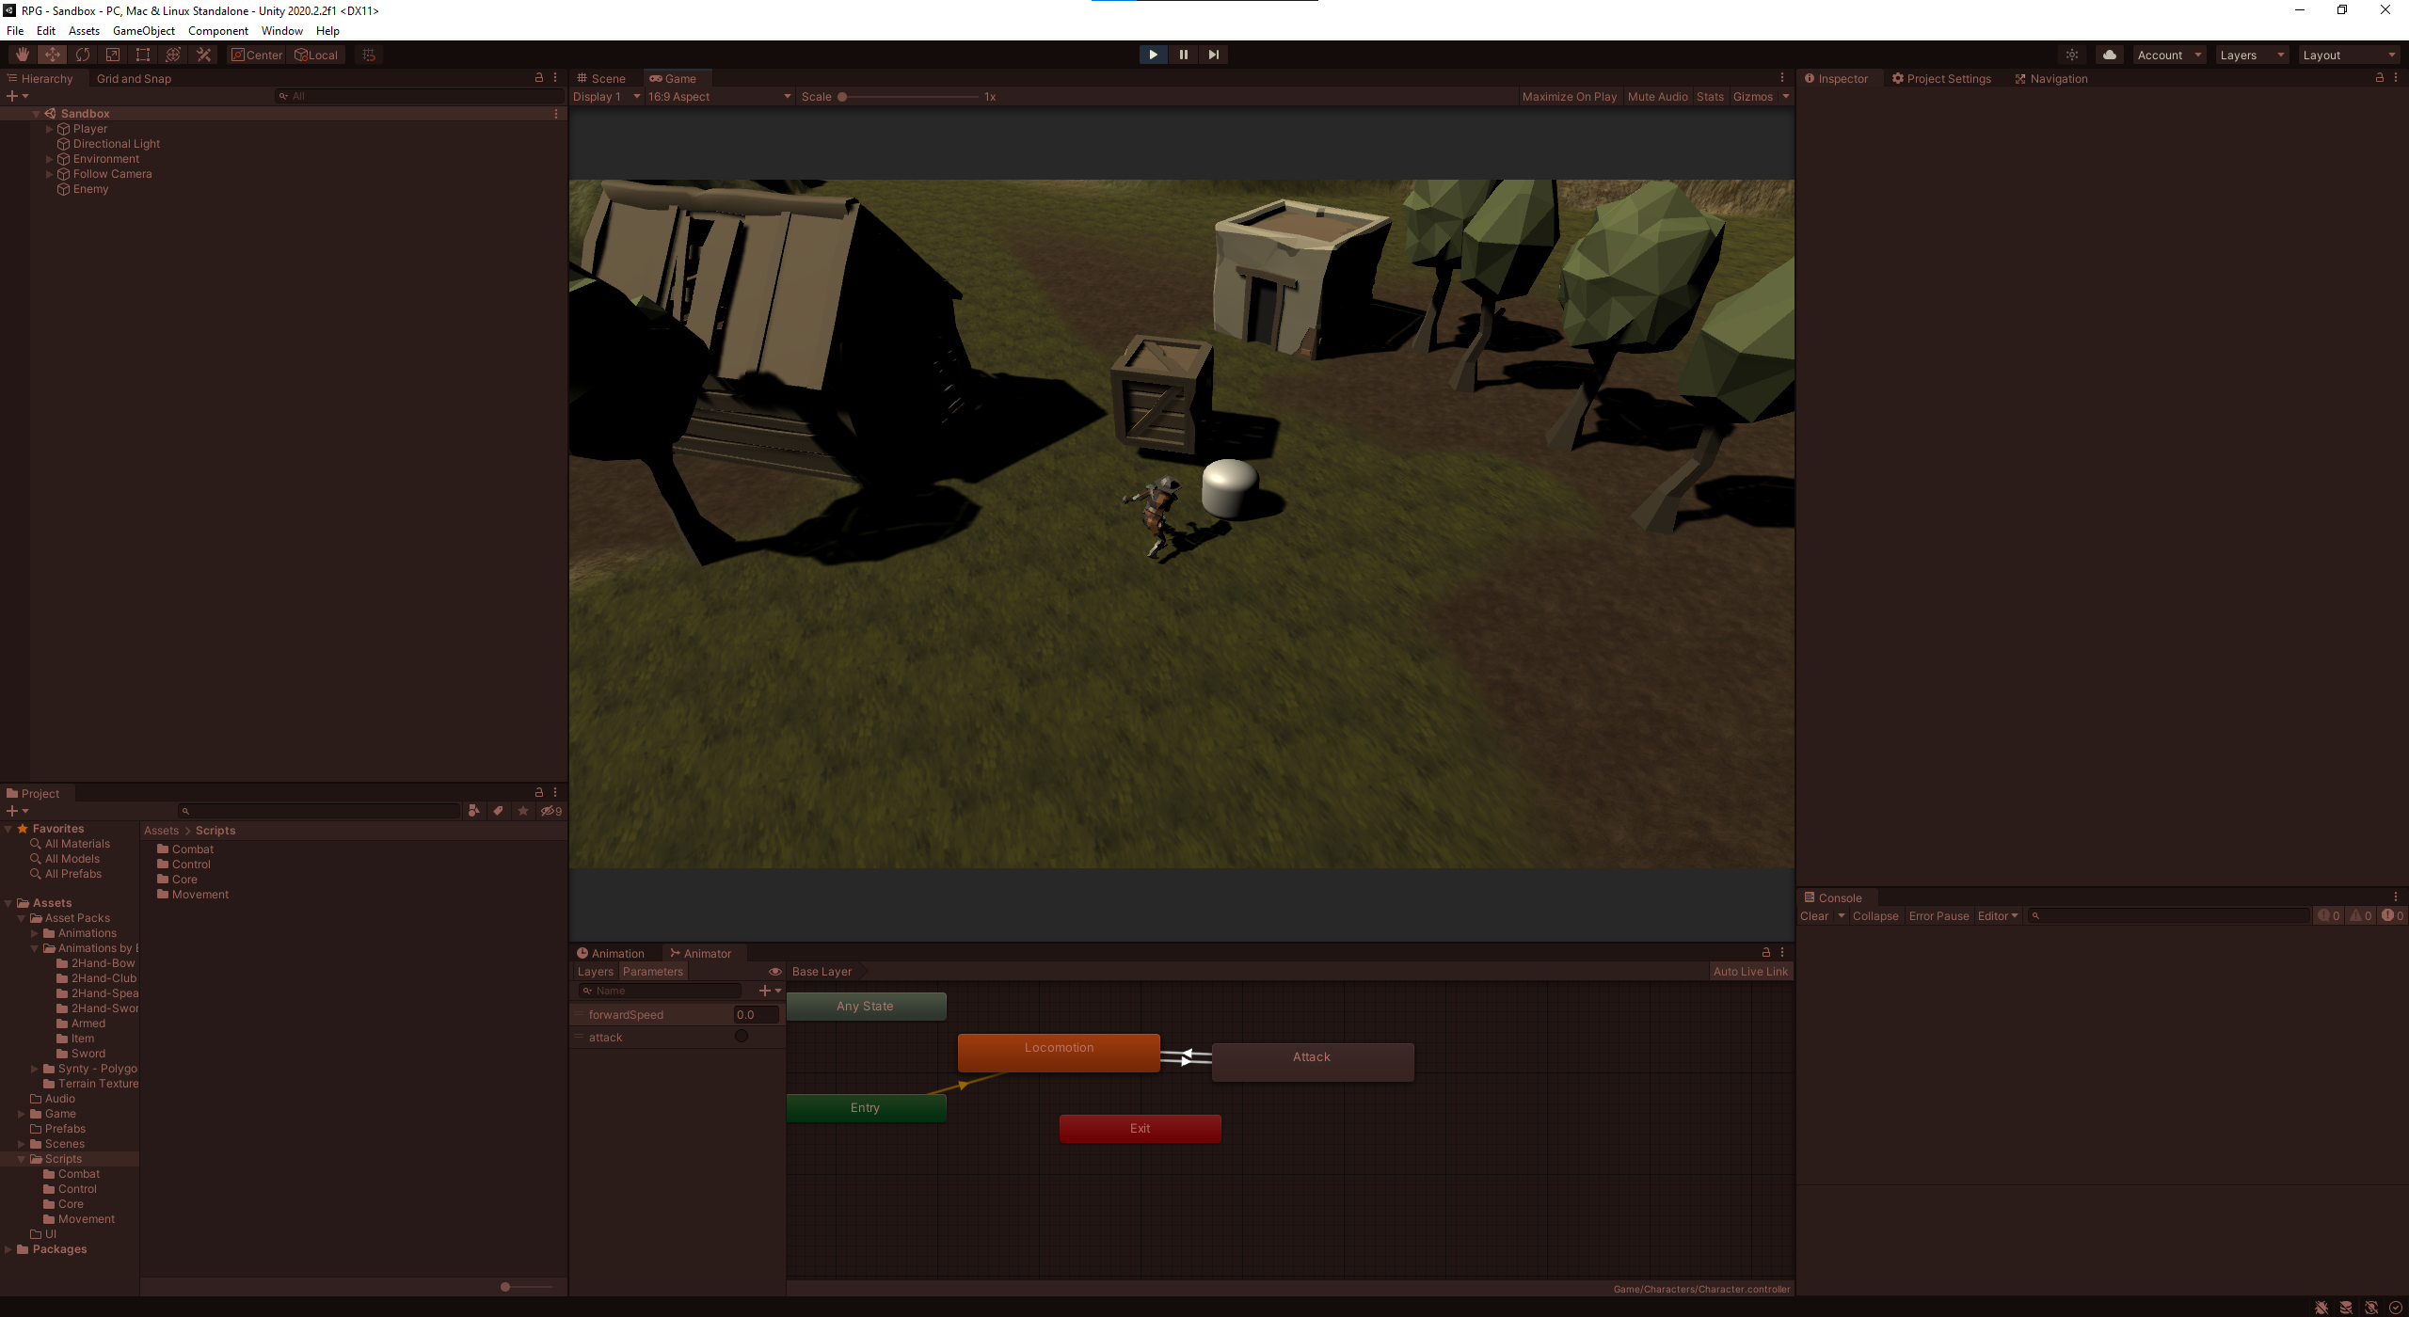

Code

I have tried to make clean and readable code so even if other developers would join the fray, they would be able to understand the flow of the projects.